Word template for manuscripts
Tim Williams
tgw@umich.edu

Abstract:
I made this document very quickly. If you have suggested improvements or there are errors, please let me know.

Introduction
This document can be used for formatting academic manuscripts with appendices. It features:
- Four levels of heading numbering
- Four levels of appendix heading numbering
- Brief instructions on using auto-captioning for your figures and tables
- Brief instructions for labeling figures/tables within appendices

Methods
Use headings 1-4 under “Home”/ “Styles” (from the top bar) for the main body of the document.

Creating a figure caption
Right click on a figure and select “insert caption” to insert a caption with auto numbering. To reference it in the text, select (from the top bar) “References” / “Captions” / “Cross-reference”, then “Reference type” is Figure and under “insert reference to” click “Only label and number”. Then it inserts it like Figure 1. It’s exactly the same for tables.
To update the numbers throughout the document, select all text and then F9.
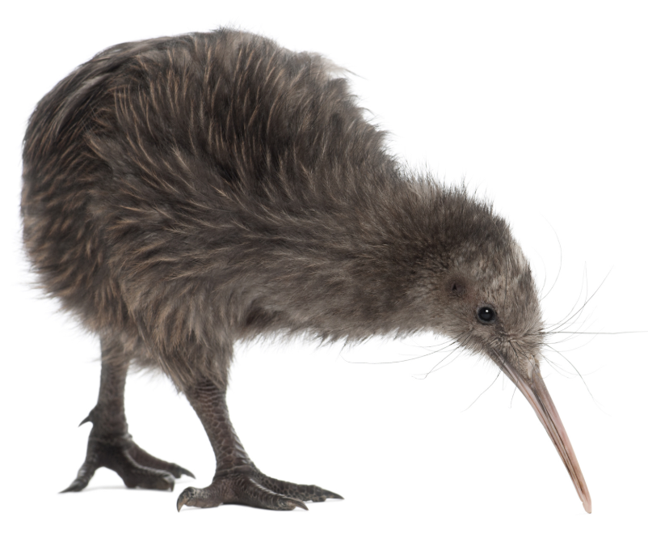
Figure 1: kiwi bird

Summary

Third level heading

Fourth level heading

use heading 5 for appendices

Section within appendix = heading 6
Text here

Figures and table captions in appendices
To reference a Figure / Table / Equation within an appendix, when entering a caption choose the “Figure_” / “Table_” / “Equation_” option. You will have to manually delete the underscore once the caption has been inserted.
IF THESE DON’T WORK FOR SOME REASON… Right click on figure. Click “Insert caption”
- Select “New label”. Give it a name e.g. Figure_apx
- Now select “Numbering”. Click “include chapter number” and then select Heading 5 (the main appendix heading)
- Click OK
- You should get a label that says e.g. Figure_apx A-1. You have to manually delete the _apx part.
- There should now be two figure (/table) caption types whenever you want to insert a figure caption – use the original one for the main body and the one you created for appendices.
Figure A-1: upside down kiwi
For example, I called my new label “Figure_” and it shows up like this (Table A-1): You can do the same with equations (Equation A-1).
Table A-1: screenshot
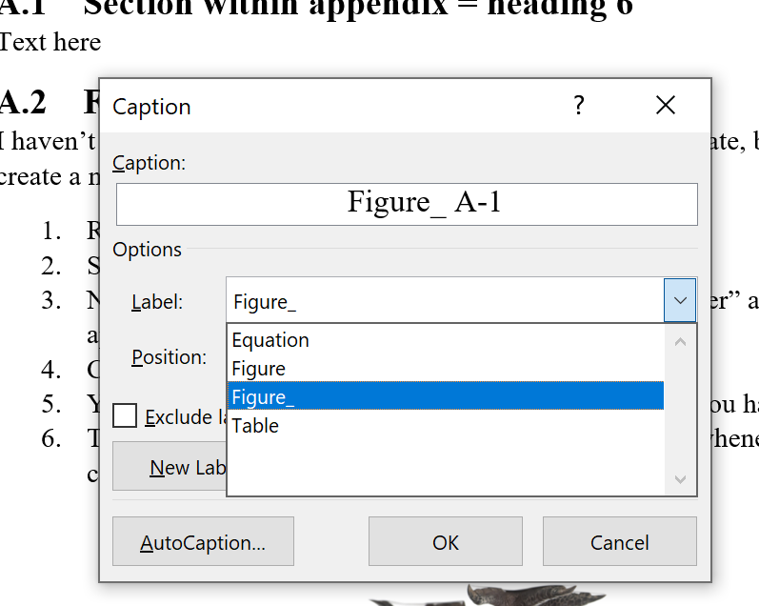
$$E=mc^{2} it helps putting equations in tables like this$$ | A-1

